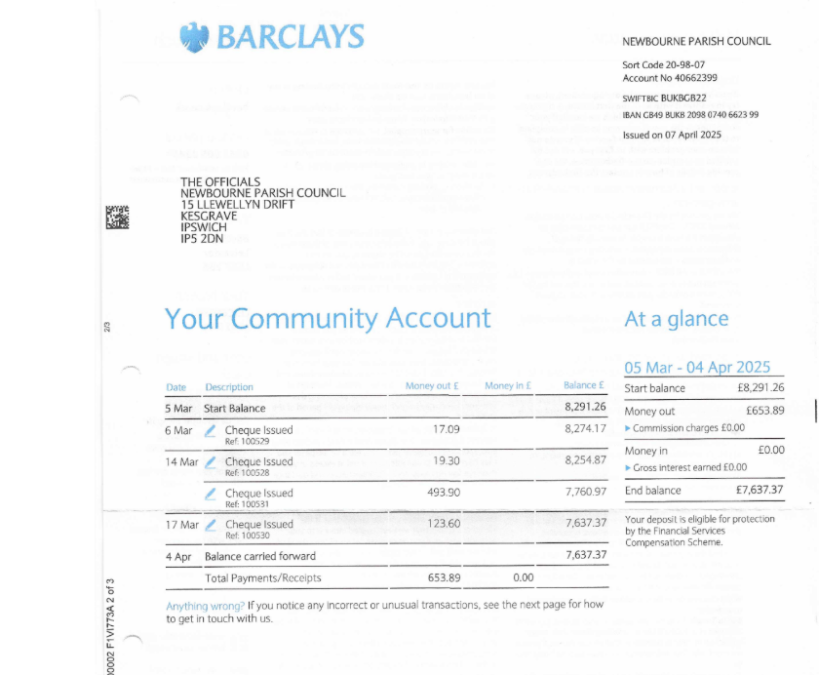
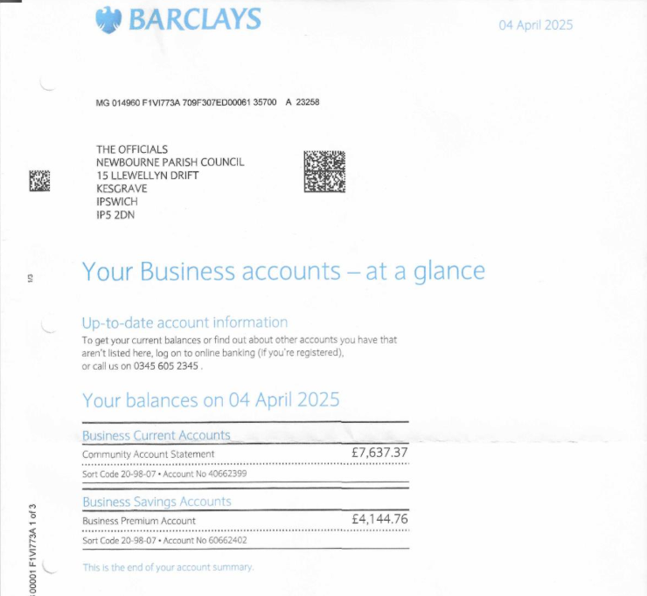

04/04/2025 | Opening Balance |  |  | £7,637.37
09/04/2025 | Money to village hall | 100538 | £1,236.00 | £6,401.37
15/04/2025 | Deben heating & plumbing | 100537 | £756.41 | £5,644.96
30/04/2025 | Precept in |  | £8,500.00 | £14,144.96

