Supporting Documents for the Parish Council Meeting – Monday 11th May 2026

West Deben Biodiversity Action Plan:
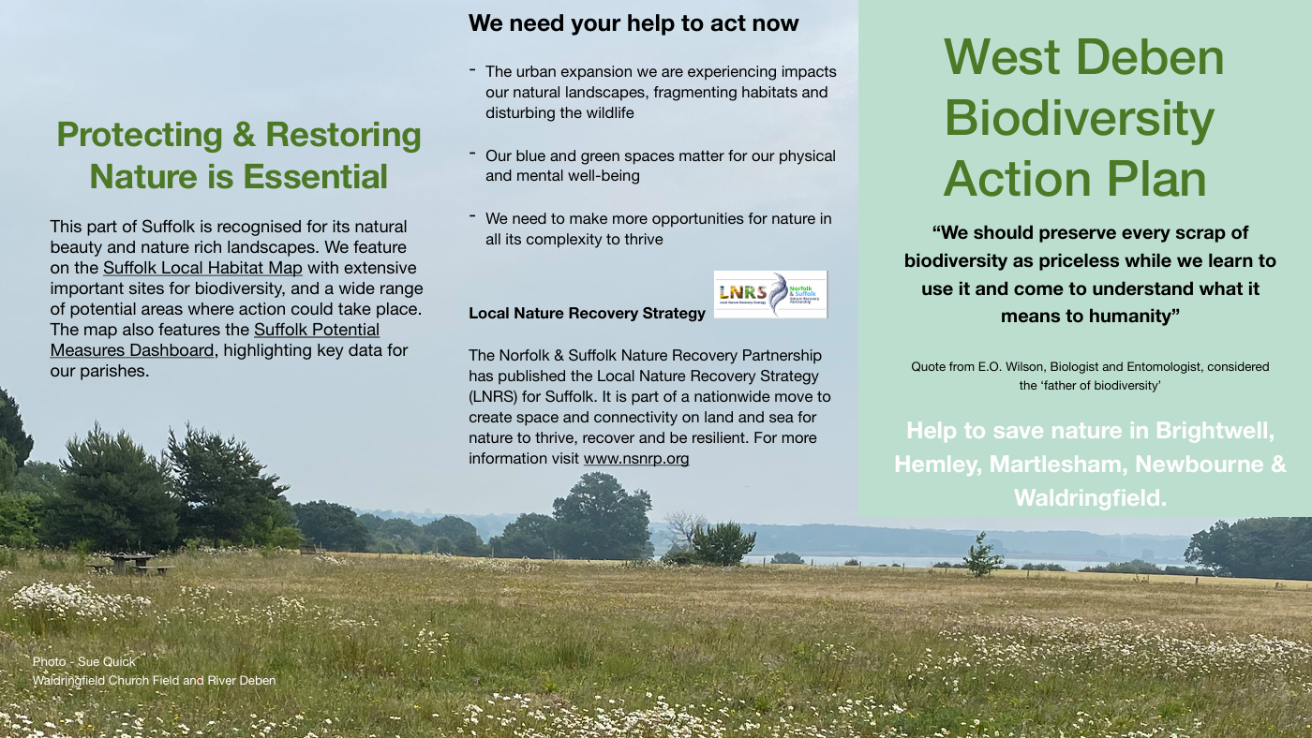
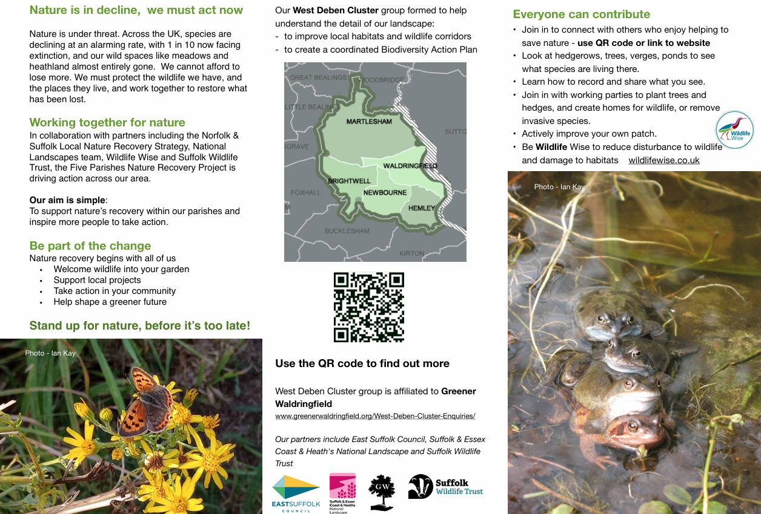

Invoices Approved During Meeting:
Cheque 100576 – New Clerk Laptop
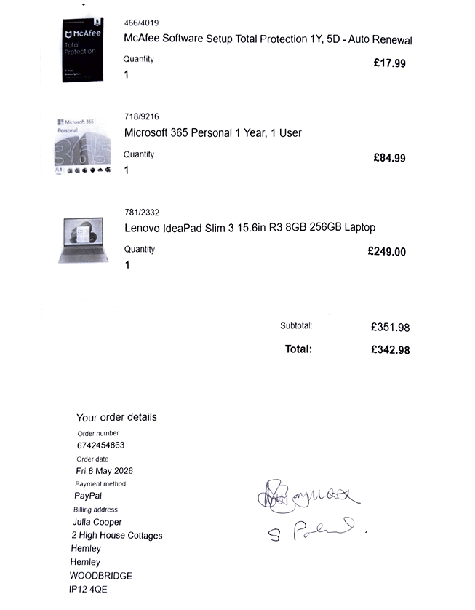

Cheque 100577 – SALC Payroll
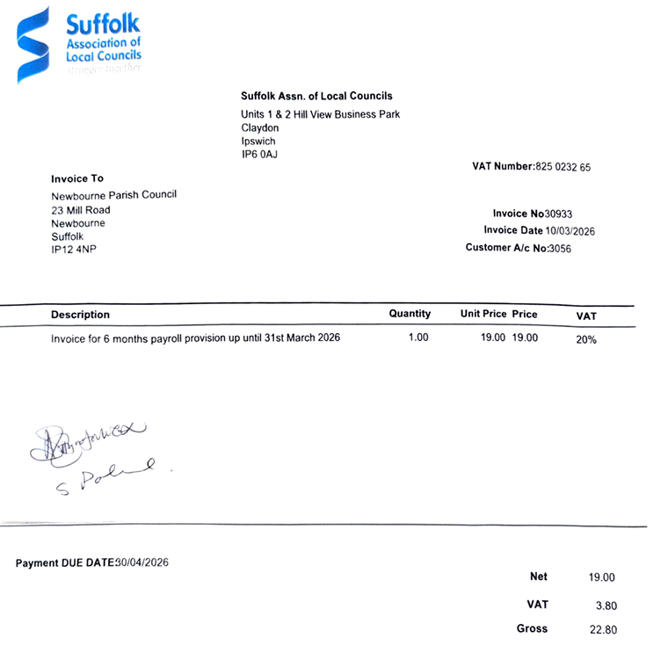

Cheque 100578 – SALC Membership
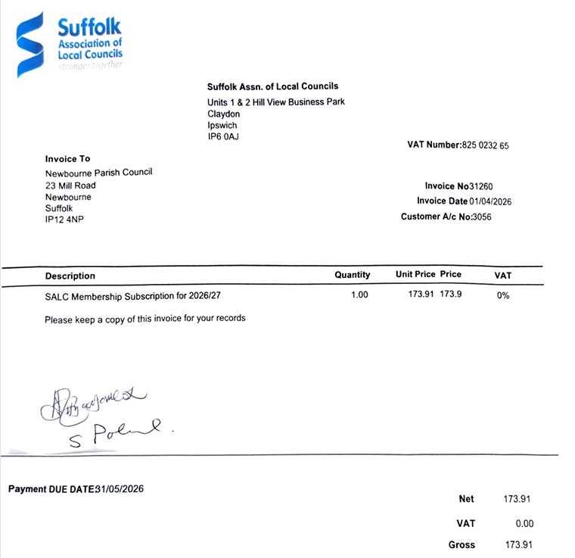

Cheque 100579 – Village Hall BT Invoice
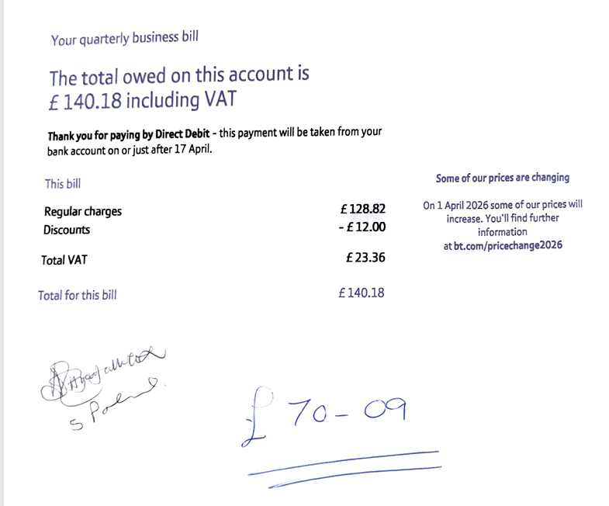

Bank Statements:


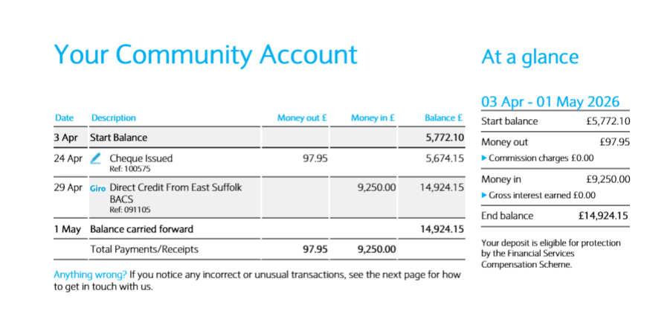
Suffolk Thriving Places Investment Fund
Briefing Paper: East Suffolk Thriving Places Investment Fund

1. Introduction
The East Suffolk Thriving Places Investment Fund is a targeted programme designed to strengthen the long‑term resilience and sustainability of the district’s market towns, villages and rural communities. It provides place‑based investment aimed at reducing inequalities, in line with our Marmot Place ambitions, enabling communities to adapt to change, protect valued assets, widen access to services and opportunities, and support sustainable local growth.
The Fund contributes to the ambitions of East Suffolk Council’s strategic plan Our Direction 2028, supporting its priorities of Environmental Impact, Tackling Inequalities and a Thriving Economy by improving local infrastructure, enhancing community capacity and cohesion and enabling inclusive participation.

2. Purpose of the Scheme
The Scheme responds to challenges faced by rural and semi‑rural communities, including a wide range of inequalities, limited access to services, declining local infrastructure, reduced social cohesion and fewer economic opportunities.
The Fund combines £1m capital and £500k revenue investment over two years (2026/27 & 2027/28) to deliver projects that will:
- Make services and support more equitable, recognising that different groups within the community have specific needs and challenges
- Strengthen local economic resilience by supporting the enterprise development ecosystem
- Enhance the quality, functionality and appeal of town and village centres
- Protect and improve community assets so they remain viable and accessible to all
- Improve access to key services/support, with a particular focus on those that increase levels of financial wellbeing, offer family support, provide skills development, volunteering or employment opportunities and/or wellbeing activities
- Enable community resilience, social connections and local pride
- Increase feelings of safety in town and village centres
- Deliver visible improvements such as upgraded community facilities, improved public spaces, greener infrastructure and enhanced visitor experiences

3. Key Themes
The programme is structured around four investment themes:

Theme 1 – Thriving Local Centres & Enterprise Development
Supports improvements that increase the economic vitality and attractiveness of local centres, including:
- Reuse of vacant units for community or enterprise use
- Public realm enhancements
- Small‑scale enterprise infrastructure
- Upgrading community buildings, for new economic activity
- Local markets and centre‑based events
- Projects to ensure residents feel safe when using local centres

Theme 2 – Participation, including Skills & Inclusion
Reduce inequalities and improves community participation, cohesion and sense of belonging, including access to skills, training, wellbeing and community activities—particularly for isolated or disadvantaged rural residents. Eligible activity includes:
- Specific projects aimed at reducing or removing inequalities between groups within the place
- Upgrading community buildings, including to encourage new uses or co‑location of services
- Enhancements to rural leisure, health and wellbeing facilities
- Local skills, employability and volunteering programmes
- Transport or outreach solutions
- Development of multi-agency community hubs offering improved access to services, support and social connection
- Support for children, young people and families, including youth participation and support and financial inclusion work

Theme 3 – Visitor Economy, Culture & Local Identity
Strengthen cultural and heritage assets and supports visitor engagement through:
- Cultural or heritage infrastructure
- Visitor facilities and interpretation
- Events, festivals and markets
- Branding, identity and wayfinding
- Community‑led creative projects

Theme 4 – Green Economy, Sustainability & Place Infrastructure
Supports environmental and low carbon improvements such as:
- Energy‑efficiency measures
- Green infrastructure and biodiversity projects
- Walking and cycling connectivity
- Nature‑based economy initiatives
- Community‑led carbon reduction activity

4. Funding Available
The Fund offers capital and revenue grants with the following thresholds:
- Capital grants: £10,000–£50,000
- Revenue grants: £5,000–£25,000
Match funding requirements:
- 70% intervention rate
- 30% match funding
- Combined capital and revenue funding may be requested, but the total grant must not exceed £50,000.
- Projects must not cover maintenance, core running costs, retrospective costs or statutory responsibilities.

5. Eligibility
Eligible areas:
All of East Suffolk, except Lowestoft and Felixstowe (town council boundaries). These towns are excluded as both already / have received significant strategic investment programmes both internally and externally. The Thriving Places Fund is designed to support smaller towns, villages and rural areas that do not typically have access to equivalent levels of investment, ensuring geographical balance and fairness across East Suffolk.

Eligible applicants include:
- Town and parish councils
- CICs, CIO’s and social enterprises
- Charities and not‑for‑profit organisations
- Constituted community groups
Private businesses may participate as partners but cannot be direct recipients of the fund. Applicants must demonstrate that relevant permissions are in place, that the project is deliverable, has match funding in place / pending, with compliance and appropriate governance arrangements. Applicants will be asked to submit supporting documentation to evidence this. All applications should be supported by the relevant ward district councillor.

6. Governance
The Fund will run over four competitive funding rounds annually. All prospective applicants must begin with an Expression of Interest (EOI), enabling the Council to assess eligibility, readiness and alignment with fund priorities.
Applicants whose EOIs are approved will be invited to submit a full application, which will be appraised and presented to the Grant Panel at the next available quarterly meeting.

6.1 Appraisal Process
All applicants will first complete an Expression of Interest (EOI) stage to assess their eligibility for the grant. Applicants whose EOI meets the required criteria will be invited to progress to the full application stage. Officers will then make a recommendation to either approve or reject the application to the grants panel.

6.2 Grant Panel
The panel will comprise of two senior councillors, three senior officers from relevant disciplines, and optional external advisers.

6.3 Meeting Frequency
The Panel will meet quarterly, with flexibility to call additional meetings as and when required.

6.4 Roles & Responsibilities
The Panel reviews appraisals, considers strategic alignment and geographic distribution, tests deliverability and value for money, and makes final decisions (approve, approve with conditions, or not approve).

6.5 Decision Making
Decisions are made by simple majority, with the Chair holding a casting vote. All outcomes are formally recorded and shared with applicants.

6.6 Transparency
Transparency is ensured through published award summaries, declarations of interest and minuted decisions.

6.7 Post‑Award Governance
Approved projects must meet agreed milestones, evidence expenditure, report progress and comply with grant conditions.

7. Summary
The Thriving Places Investment Fund provides a strategic and flexible mechanism to support small town, rural and semi‑rural revitalisation across East Suffolk. Its governance framework ensures transparency and robust decision‑making, while its thematic structure enables the delivery of economic, social, cultural and environmental benefits for local communities.

