Supporting Documents for the Parish Council Meeting – Monday 1st June 2026

Invoices Approved During Meeting:
Cheque 100580 – Clerk Wages
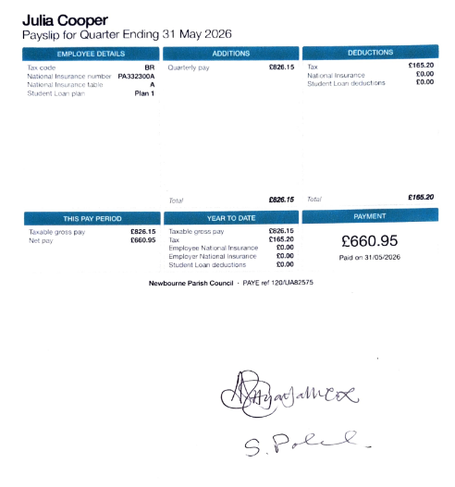
Cheque 100581 – Playdale Deposit
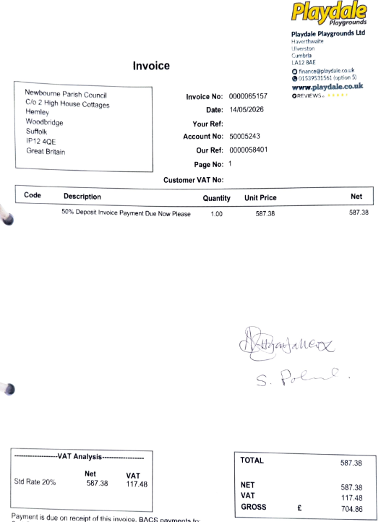

Bank Statements:
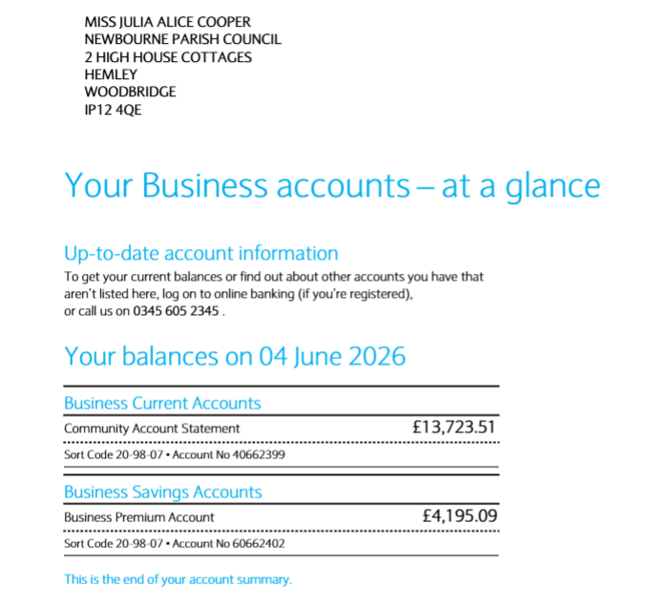
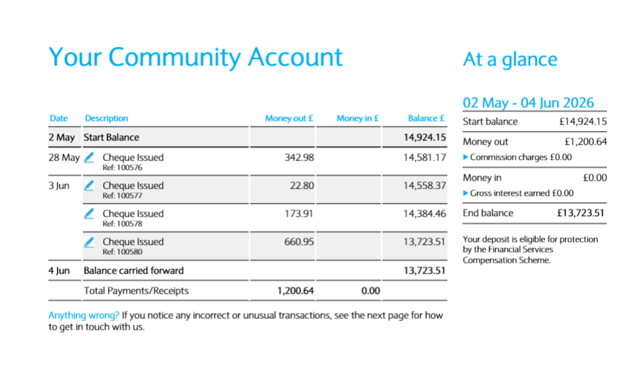

PARISH REPORT MAY 2026
ORWELL & VILLAGES

Never Miss a Collection with the New East Suffolk App
A new app has been launched to help East Suffolk residents with the changes to recycling which begin in June.
The app helps residents to quickly see which bin is due for collection each week and will help people check what can be put into each bin, to help people recycle even more.
There is also the option to receive reminders ahead of bin collection day and receive alerts if a scheduled bin collection has been delayed through bad weather or a traffic issue.
The new app also enables people to find nearby council-owned car parks, leisure centres and public toilets, as well as local places to eat and their associated food hygiene rating.
GLI Cllr Paul Ashton, East Suffolk’s Deputy Leader and cabinet member for Corporate Services said: "The new East Suffolk app will help residents adjust to the changes to recycling services which are being introduced across the county on 1 June, making it even easier for people to check their collection day, the colour of bin being collected and check what items can go into each bin.
“In addition to recycling information, our new app also enables people to find nearby council-owned facilities such as car parks and public toilets, report issues directly using our online forms and check the food hygiene ratings of local places to eat, with more services to come in due course.”
The new app is available for Apple and Android in the app store (search for East Suffolk).
The new Better Recycling service launches in Suffolk from 1 June and from this date, residents will be able to recycle more items, including glass and soft plastic, through their recycling bins at home. The collections will be as follows:
• A weekly food waste collection (grey food container)
• A three-weekly general rubbish collection (black lid bin)
• A three-weekly recycling collection for glass, plastics, metal and cartons (blue lid bin)
• A three-weekly recycling collection for paper and card (green lid bin)
To help residents recycle even more, the new East Suffolk app has a handy recycling search tool to check whether an item can be recycled. There is also an AI powered image search which enables residents to take a photo of an item and check whether it can be recycled, and in which bin.
The new app is fully accessible and is voice reader compatible.
Suffolk Councils Launch Reorganisation Website
www.suffolklgrhub.gov.uk
A new website providing trusted information on Local Government Reorganisation (LGR) in Suffolk has been launched by the county’s 6 councils.
The website, named Future Suffolk, is part of a shared commitment by the county, district and borough councils to ensure residents and communities understand LGR and what it means for them.
The site brings together key information, helping to communicate upcoming changes in a clear and consistent way. It also offers a single point of contact for residents, allowing them to submit any questions, comments and concerns.
The Future Suffolk website includes:
• Clear explanations on LGR
• A timeline of key milestones
• Maps of the new council boundaries
• An interactive map showing provisional ward names and boundaries
• Information on councillor numbers
The website also outlines proposed names for the new unitary councils and the details of the electoral wards within them - these are required as part of the legal process to establish the three new councils. The proposed names are Central and East Suffolk, Ipswich and South Suffolk, and West Suffolk.
Once established, the new councils will have the ability to review these names.
The website launch comes following government’s announcement in March 2026, that three new unitary authorities would replace the current county, district and borough councils.
Elections for the new councils will take place in 2027 ahead of the first day of operations (known as ‘Vesting Day’), when the new authorities formally assume their responsibilities.
LGR is a national programme across England to simplify and modernise local government structures, typically by replacing multi-tier systems with single unitary councils responsible for delivering all local services.
Ease the Squeeze on Cost of Living
Are you, or someone you know, worried about the increasing cost of living? We understand the pressures faced by many people today and we are working closely with key partners to ensure support is available to help ease the squeeze for households in East Suffolk.
To make it as easy as possible for you to access the services and support available, locally and nationally, we have gathered information about them in one place:
www.eastsuffolk.gov.uk/community/squeeze/
Community Spaces Set to Flourish as Bulb Giveaway Returns
East Suffolk Council will be giving away thousands of early spring flowering bulbs as its annual East Suffolk Blooms campaign returns for 2026.
Back for the fourth year, town and parish councils, community groups and organisations are invited to apply to receive free packs of pollinator-friendly bulbs to plant next spring.
The scheme works in tandem with the East Suffolk’s Amazing project which encourages everyone to maintain the beauty and cleanliness of the district, and last year established 25,000 narcissus ‘Carlton’ bulbs in the autumn, that emerged to brighten communities across the district earlier this spring.
This year, to provide greater benefit to pollinators, the council is offering mixed crocus bulbs, which is one of the earliest flowering plants that support pollinators emerging from hibernation, and is encouraging groups that missed out last time to apply.
Packs of the crocus bulbs will be available to collect in the autumn, around October, from two locations in the district.
The scheme is funded by East Suffolk Council’s trading company and services operator, East Suffolk Services Ltd, which will be providing £3,000 worth of flowering bulbs.
An application form will be available to complete online until 31 August, before a judging panel decides on successful applicants, with additional consideration given to groups reapplying after missing out last year. Applicants will be informed of the decision by September.
To apply, please visit: my.eastsuffolk.gov.uk/service/east_suffolk_blooms

As always if parish councillors need to contact either of us, please feel free to do so.
Cllr Mike Ninnmey: Home tel no 01394 277610 Mobile: 07823 372503
E-mail: mike.ninnmey@eastsuffolk.gov.uk
Cllr Lee Reeves: Home tel no 01394 284506 (preferred) Mobile 07823 372501
E-mail: lee.reeves@eastsuffolk.gov.uk

