Supporting Documents for the Parish Council Meeting – Monday 6th July 2026

Invoices Approved During Meeting:
Cheque 100582 – HMRC P30
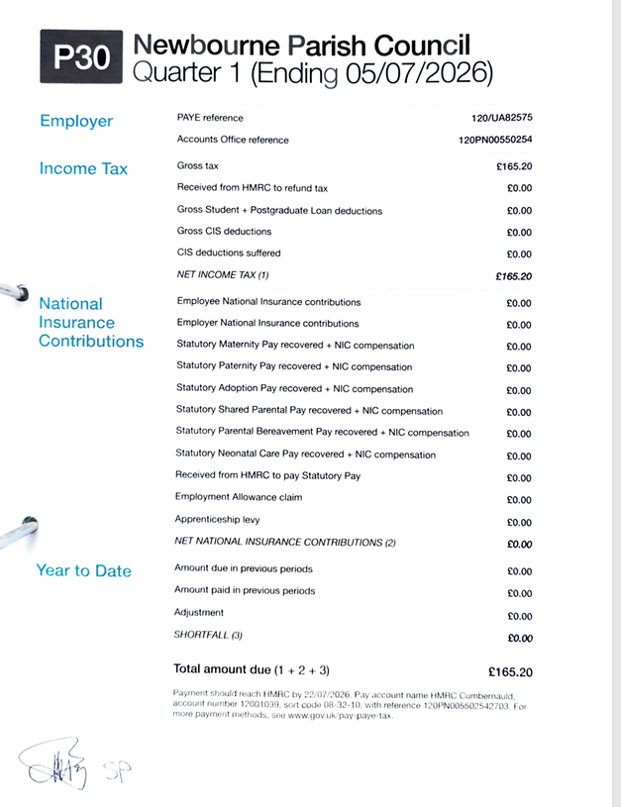

Cheque 100583 – BT Broadband
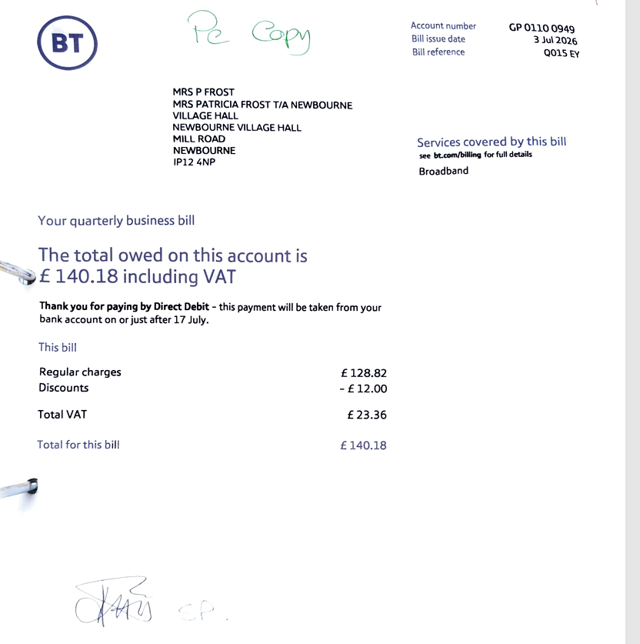

Bank Statements:
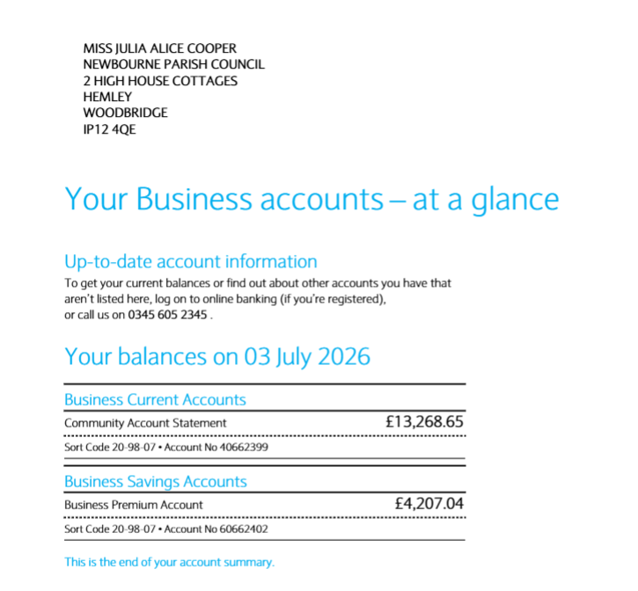
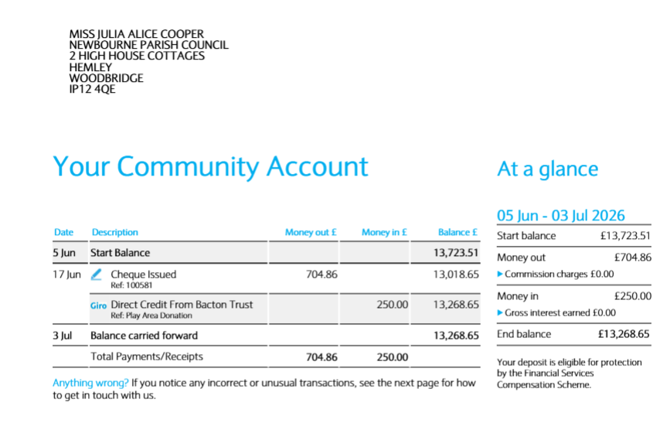

Responses to The Report on the Street:
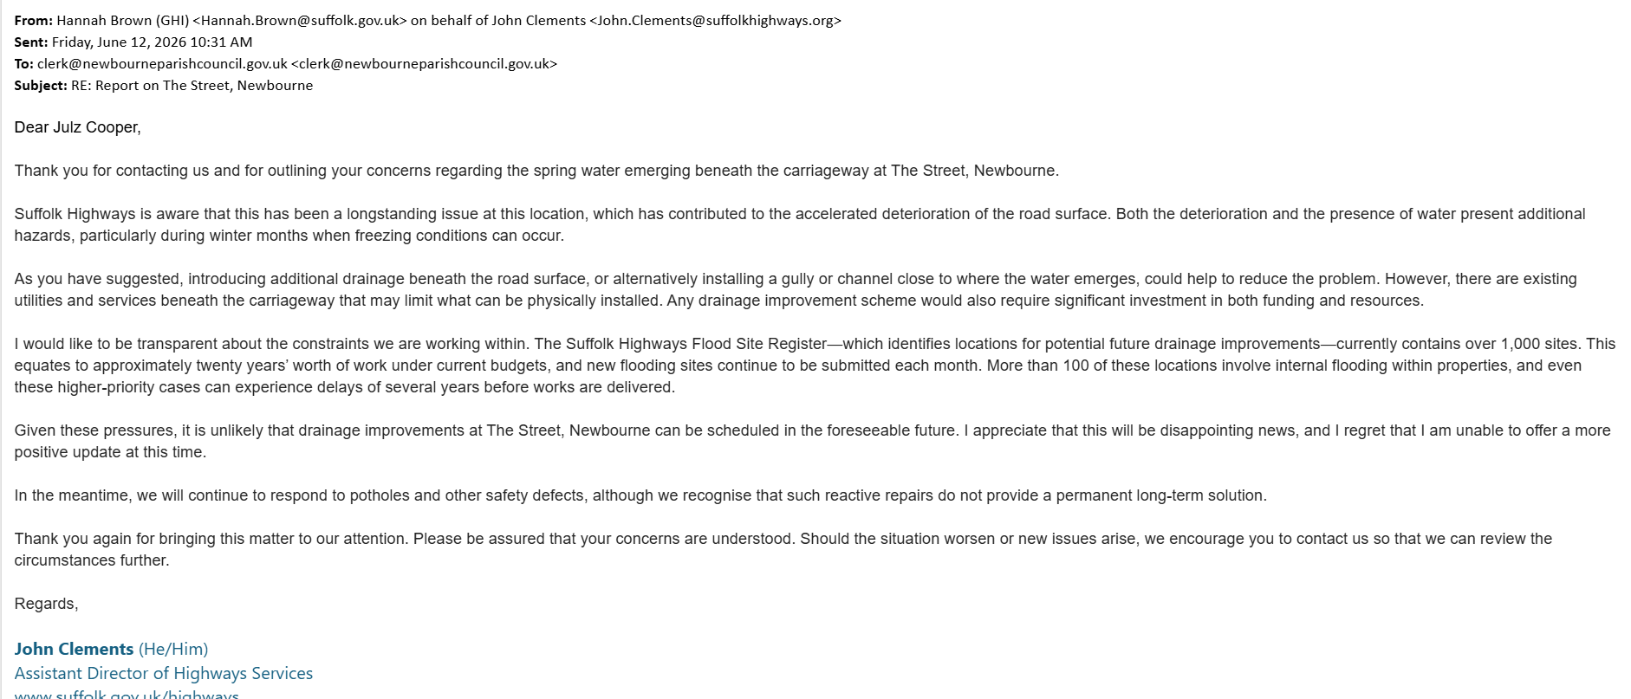
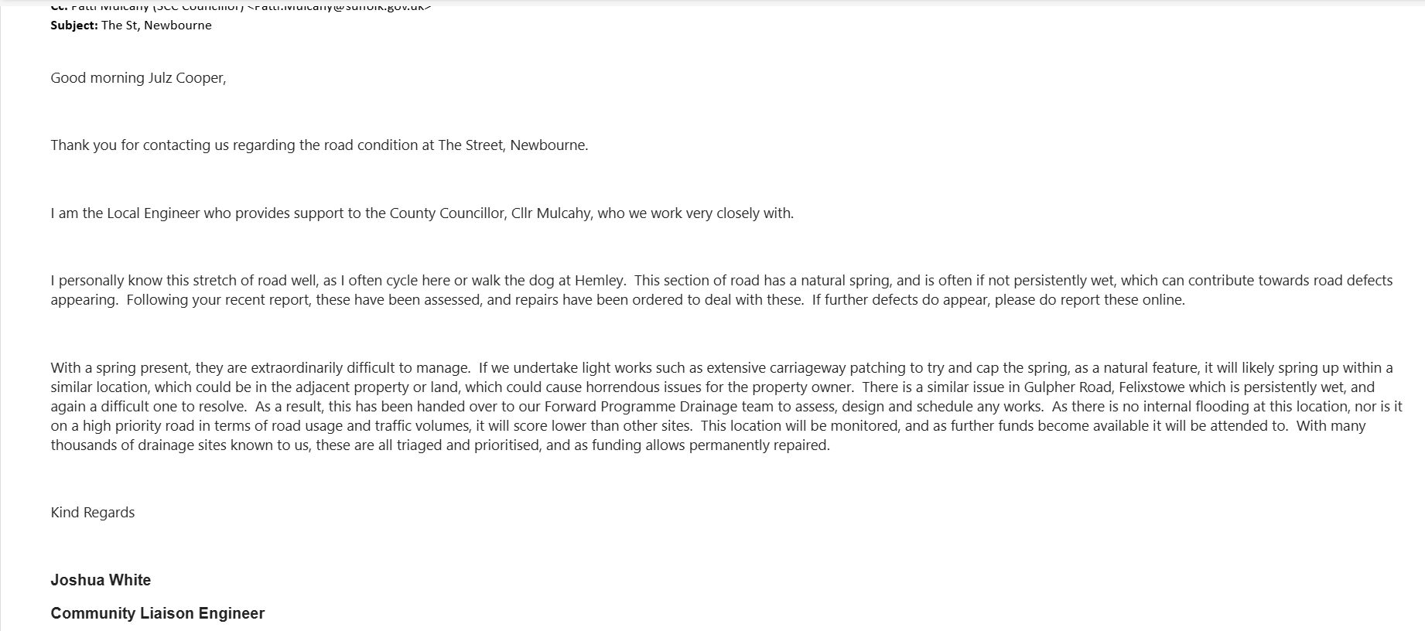

Objection Raised to Planning Application:
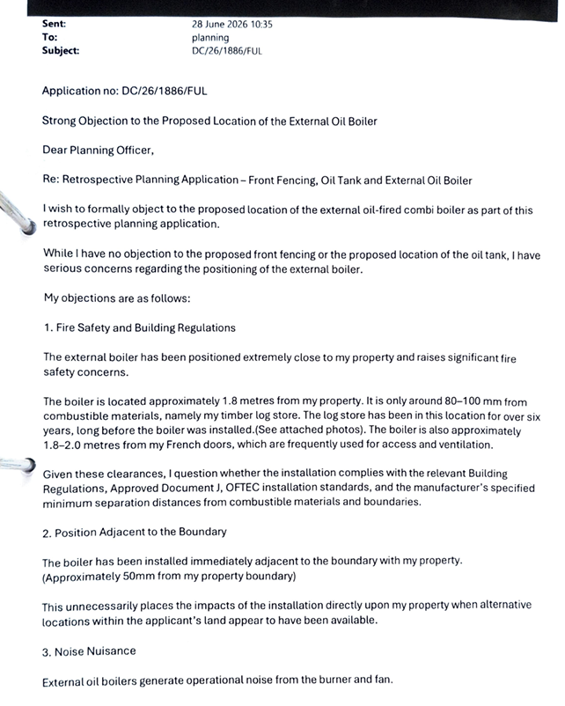
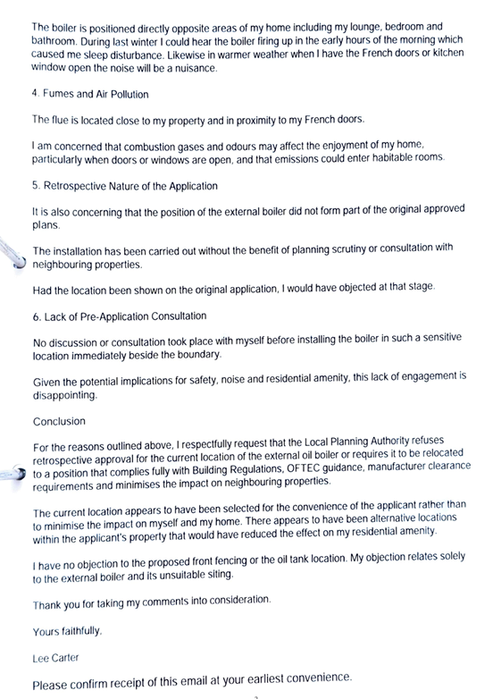

PARISH REPORT JUNE 2026
ORWELL & VILLAGES

Waste Collections – apology and explanation
As councillors we are acutely aware of the very real problems that the current poor waste collection service is having on many residents particularly in our more rural areas. We must apologise at the outset but wanted to set out what ESC is doing at present and the plan to return the service to normal levels.
The Cabinet met with the Strategic Directors and senior staff last Wednesday (24th June) and the following statement was sent out to all councillors on Friday (26th June). Whilst it is fairly long, we feel it is worth sending to all parish councils and if possible, for parishes to forward onto their residents.
We would stress that the position is fast moving and the council will endeavour to update as often as possible on the ESC app. We realise however that only around one third of residents are signed up for the ESC app at present so if you can inform your neighbours that would be appreciated.
One item not mentioned in the statement is that ESC, in common with many councils, have only received a proportion of the additional costs for the national roll-out of this scheme from Westminster. In our case the shortfall is roughly £ 1 million which we are having to find from other budgets or reserves.
“This is not an acceptable level of service; I am the lead for this and wanted to provide you with reassurance that I am aware that we need significant improvements. This has been a major, complex exercise, with changes to almost all parts of the system – routes, rounds, staff, contracts and collection streams. It was inevitable that this would cause pressure in the system – but we are seeing unacceptable levels of disruption that we will get right in the coming weeks.
While it is a complicated picture and not everything will fall into the following categories, there are two issues that have impacted collections this week:
Potential issues with the length of rounds in rural parts of the district – we are reviewing these with ESSL
Heat related absence – the operation in Ufford in particular has been impacted by high levels of staff absence, primarily affecting loaders and some drivers.
What we are doing about it:
Officers are working closely with East Suffolk Services to understand the causes of underperformance in certain collection rounds. This work is our number one focus and includes daily monitoring and analysis of operational data, alongside a review of routes to determine where adjustments may be required to improve reliability and efficiency. Paul Ashton, Chris Bally and I – along with operational colleagues - are meeting the senior management team at ESSL – including the Managing Director and Director of Operations - regularly to review performance and their mitigation plans, in addition to daily monitoring.
At those meetings we are reviewing:
All data from the previous week
A look ahead at operational issues that might impact the service
Staffing resilience
Vehicle and fleet issues
Traffic & Routes – in particular, where issues may present themselves in the week ahead, and what the plan is to mitigate this
New rounds and new processes – including identifying where the reality of routes is departing from the detailed modelling we did when preparing for Better Recycling
Communications – what are we saying to residents and members about collections
What ESSL are doing about it:
ESSL have been managing absence by using additional crew capacity, ensuring that crews assist other areas where bins have been missed, while trying to bring in agency staff and part time staff to make up for staff shortfalls. Additional vehicles are available, and if staffing allows, additional catch up rounds are being put out, including at weekends and on Mondays – which are, ordinarily, non-collection days. Crews are starting earlier during periods of hot weather, and have been provided with opportunities for additional rest breaks. Clearly – this can have an impact on collection rates.
In terms of performance – we are still collating the data for this week, but it does appear that there has been an improvement in the number of food collections this week. Last week, 59% of food collections were made. On Tuesday of this week, it was 75%. On Wednesday it was 69%. Yesterday, nearly 80% of food bins were collected. The intention is that – for those areas that were missed this week – these are prioritised for collection next week
Message to residents whose bins have been missed:
While missed collections can always occur, there has been a knock-on impact on other waste streams, as crews aim to ensure food waste issues are addressed.
Any missed collections should be reported by residents to the Council: Missed bin collection - My East Suffolk.
ESSL crews will endeavour to return to missed bins as quickly as possible.so, if you can, please leave your larger bins out for collection if they are not emptied. ESSL will be aiming to provide weekend and Monday collections to cover missed rounds.
Where wheeled bins are missed – crews will be aiming to prioritise the collection of residual and garden waste bins.
Advice about outstanding delivery of new bins:
Around 98% of new bin deliveries have now been completed.
If customers have not received their new bin(s) they should contact the Council: Better Recycling bin delivery issue - My East Suffolk.
Once this is reported, there is no need to contact the council again
We fully appreciate the frustration being experienced by residents and members. Significant time and resources are being dedicated to resolving these issues, and ensuring the service reaches the expected standard is our top priority.
We will continue to keep the situation under close review and provide further updates as improvements are delivered. We also recognise that communications is important and we will continue to provide regular updates via the app, social media, the press and via our customer services teams who are doing an incredible job supporting residents. We will also use the Council website to provide general advice about the overall picture with instruction for residents whose collections are missed – we have now published our latest update: Waste and recycling collection delays | East Suffolk Council
Thank you for your continued support and for relaying resident concerns, which remain vital in helping us target areas requiring attention.”
This is clearly a position we would not wish to be in but hopefully residents would agree that the priority now should be to clear the food waste collection first, followed by the residual bins. This may result in some other bin collections being delayed. Garden waste contracts are likely to be extended. Please follow the advice on the ESC app and do please report missed bin collections as above so remedial action can be taken
If you have not yet received your new bins, please do report this as above as pretty much all routes are delivered now although there may be some isolated houses missed especially in rural areas.

Friends of the Earth- Environmental data for Orwell & Villages
Friends of the Earth have created a very useful report for each district council ward which has been passed to councillors.
A full copy of the report is available at: Orwell-and-Villages-env-report.pdf - Google Drive
The key points reveal that 2,519 homes in Orwell & Villages are poorly insulated with EPC ratings below EPC-3. This equates to 56% of homes in the ward which would require an upgrade before they can be sold. On these figures the ward is 17th out of 29 wards requiring upgrades.
The summer tree canopy cover in the ward is currently 7.3% against a recommended level of 20%. Trees provide both shade and reduce flooding whilst improving air quality. On the bright side 100% of our residents live within a 15-minute walk of a green space.
Orwell & Villages ranks 12th out of 29 wards for pollution levels with parts of the ward reaching 14.7 ug/m3 for nitrogen dioxide against the WHO recommended level of 10 and 7.5 for particulates against the WHO recommended level of 5.
Information regarding other wards in East Suffolk or in other council areas can be found on the Friends of the Earth website.

Cadent works on Trimley High Road
We have been disappointed by the lack of engagement by Cadent and their representatives in relation to the gas pipe replacement works taking place on High Road Trimley and some roads off which are due to last for four months.
We were only advised less than a week before works were to commence of a “consultation” event to be held on 22nd June, the very same day as the works were due to commence. We wrote to Cadent seeking confirmation that bus routes and stops would not be affected, pointing out they had not included Trimley St Martin parish council in their invitation, and asking for confirmation that ESC had been consulted to ensure waste collections would continue during this period.
The works started on 23rd June with no advance warning signs in place and the traffic light controlled single lane has taken two bus stops out of commission at least temporarily. Cadent’s representatives had advised bus stops would be unaffected and had also told us that they were not obliged to consult with ESC on waste collections. ESC has confirmed that they will endeavour to continue all waste collections along High Road although this could lead to minor hold-ups for traffic whilst they do so.

Ease the Squeeze on Cost of Living
Are you, or someone you know, worried about the increasing cost of living? We understand the pressures faced by many people today and we are working closely with key partners to ensure support is available to help ease the squeeze for households in East Suffolk.
To make it as easy as possible for you to access the services and support available, locally and nationally, we have gathered information about them in one place:
www.eastsuffolk.gov.uk/community/squeeze/

As always if parish councillors need to contact either of us, please feel free to do so.
Cllr Mike Ninnmey: Home tel no 01394 277610 Mobile: 07823 372503
E-mail: mike.ninnmey@eastsuffolk.gov.uk
Cllr Lee Reeves: Home tel no 01394 284506 (preferred) Mobile 07823 372501
E-mail: lee.reeves@eastsuffolk.gov.uk

