Supporting Documents for the Parish Council Meeting – Monday 3rd August 2026

Invoices Approved During Meeting:
Cheque 100584 – IT Services @ CAS
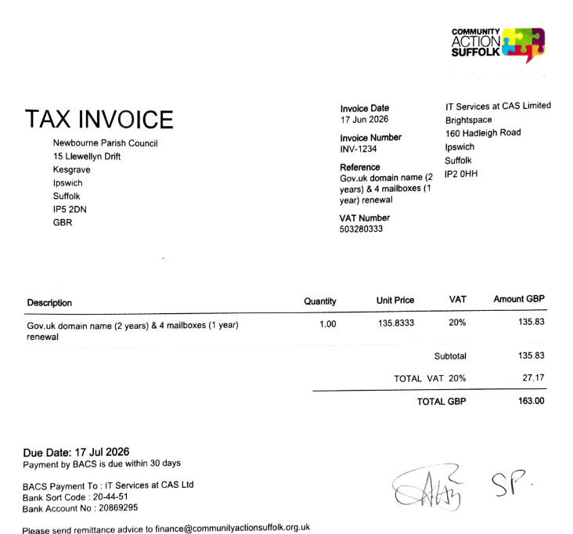

Cheque 100585 – Clerk Receipts
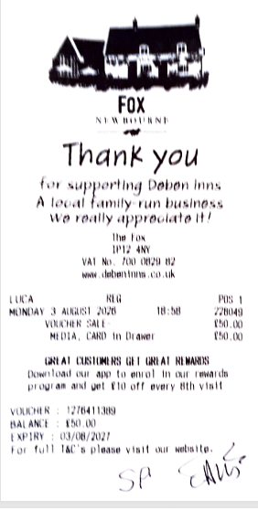

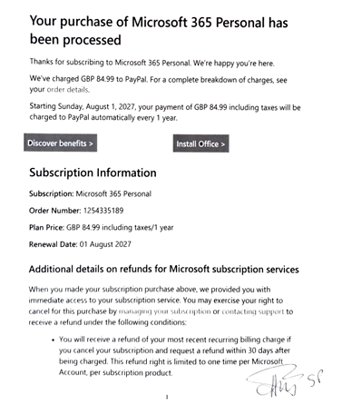

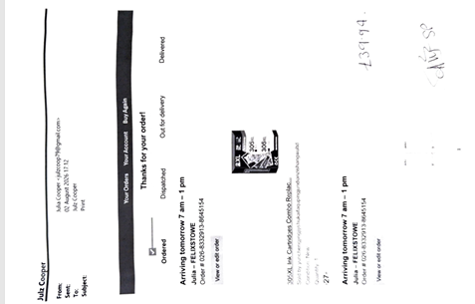

Bank Statements:
