Supporting Documents for the Parish Council Meeting – Monday 13th April 2026

Email from Local Resident:
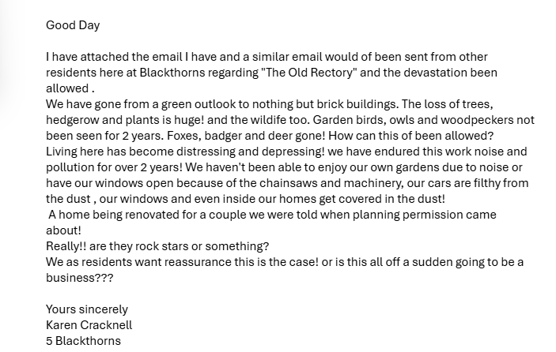

Invoices Approved During Meeting:
Cheque 100575 – Clerk Receipts
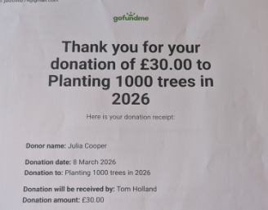
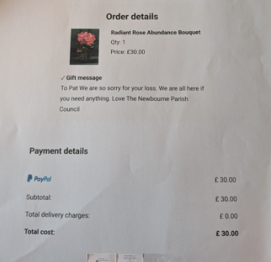

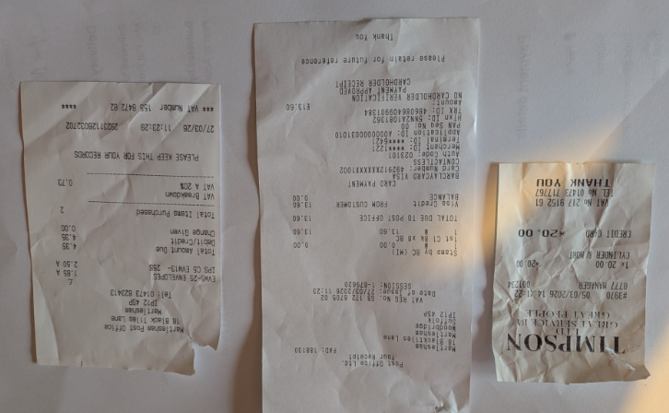

Work Completed by Cllrs Foster & Gaussen:
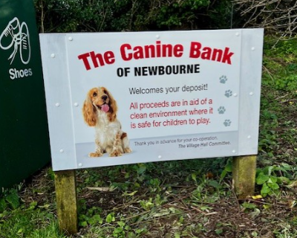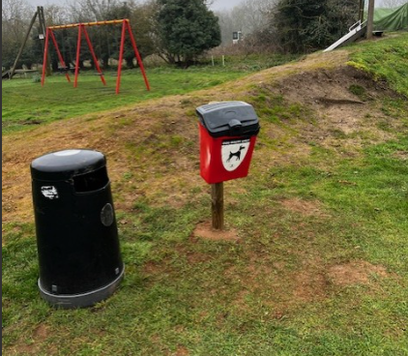

Wicksteed Quote:
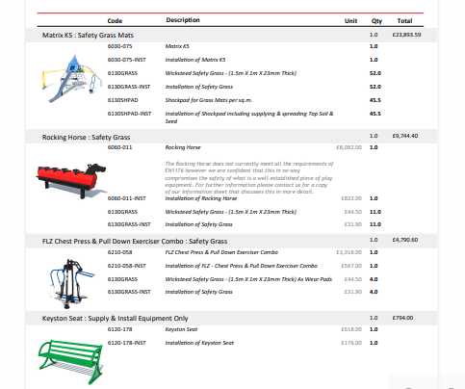
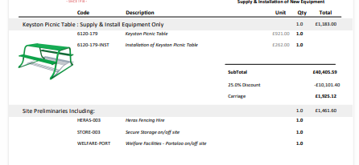

Bank Statements:
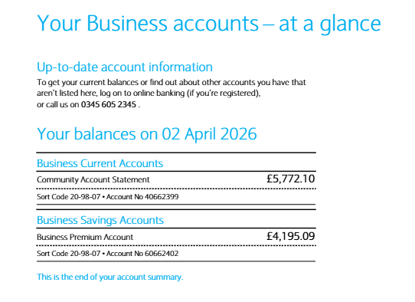

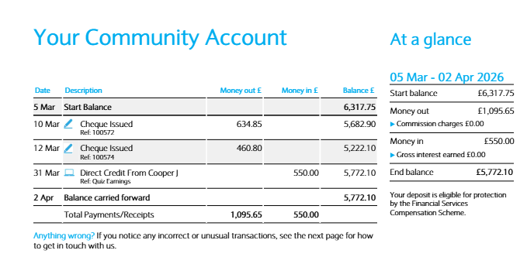

Parish Report March 2026:
Local Government Reorganisation approved
The Secretary of State for Housing, Communities and Local Government has confirmed that three unitary councils will be created in Suffolk replacing the current system made up of Suffolk County Council and the five district and borough councils: Babergh, East Suffolk, Ipswich, Mid Suffolk and West Suffolk.
Under the new arrangements, the new councils will come into operation in April 2028, with elections scheduled for next year to establish the shadow authorities responsible for shaping and overseeing the transition.
The six existing councils have already started the preparatory work, but will now begin detailed planning on the transition, with further information to be shared once plans are confirmed.
Felixstowe and our villages will now be included in a new unitary authority understood to be Ipswich and South Suffolk with Ipswich, Babergh and part of Mid Suffolk. As you will be aware we had both pushed unsuccessfully for a two unitary option to be submitted to Government.

Call for Sites submissions
Early preparation has begun on a new East Suffolk Local Plan. This will set out how and where development, including new homes, employment land and infrastructure, should take place up until at least 2044. The new plan will replace the existing Suffolk Coastal and Waveney Local Plans. The new Local Plan is anticipated to be adopted in 2029.
A Call for Sites was held between Monday 20 October 2025 and Friday 9 January 2026 and invited submissions of sites for consideration for inclusion in the new Local Plan. This is the earliest stage of the Local Plan process and it purely helps us to know what land is available for our consideration.
A total of 503 sites were put forward across the whole district and these have now been mapped. The map can be viewed on the following link A new Local Plan for East Suffolk | East Suffolk Council. The published map displays the sites’ location and the use proposed by the submitter (for example housing or employment).
At this stage the map has been published for information purposes only and ESC are not inviting comments, however there will be opportunity to comment on these sites when they consult communities later in the process.
It is important to note that:
- No assessments have been undertaken, and no decision has been made on which sites will be included in any future Local Plan, this map simply displays the submitted sites.
- The new Local Plan, including any future allocations, will be informed by a range of evidence, assessments and the outcomes of public consultations.
- The sites have no planning status (other than sites which are already allocated or permitted, in which case a submission does not alter this status).
- Sites have not necessarily been submitted by the landowner – submissions were invited from anyone who wished to submit a site.
- Existing allocations and permissions are not shown on this map. This map shows sites submitted during the Call for Sites only, further sites may come forward through the Local Plan process.
- We recognise that communities may wish to express their comments on sites, however we will not be formally inviting or considering any comments received at this time. Submission of comments should be reserved until future consultations.

Place Shaping Consultation
East Suffolk Council is encouraging people to get involved in a new project designed to capture local opinions about the district.
The new East Suffolk Place Shaping project aims to enhance the quality of places in the district by creating new or improving existing planning policy.
An interactive map is available on the project website, allowing participants to pinpoint places in East Suffolk they like, dislike, or believe should be improved. Participants are also invited to complete a short survey to provide further detail about their views.
You can share your views through the project website by:
📍 Adding pins to the interactive map to highlight places you like, places that could improve, or opportunities for the future.
📝 Completing the online East Suffolk Place Shaping survey to share your views on placemaking priorities in East Suffolk. Anyone who lives, works or visits East Suffolk is invited to participate in the project, which will help to inform planning guidance throughout the district.
The consultation is open until Friday 24 April, and an insights report will be published once all responses have been gathered. As the interactive map allows residents to pinpoint those areas where they feel unsafe and suggest improvements, the findings will be shared with the Community Safety team to take action.

Thriving Places Fund
The commencement of this new fund for smaller communities has been delayed until May due to the purdah period for the County Council elections.
The link for full details is Thriving Places briefing paper PW.docx
We would urge our smaller parishes to seek funding from this should they be unable to access CIL funding.

Ease the Squeeze on Cost of Living
Are you, or someone you know, worried about the increasing cost of living? We understand the pressures faced by many people today and we are working closely with key partners to ensure support is available to help ease the squeeze for households in East Suffolk.
To make it as easy as possible for you to access the services and support available, locally and nationally, we have gathered information about them in one place:
www.eastsuffolk.gov.uk/community/squeeze/

As always if parish councillors need to contact either of us, please feel free to do so.
Cllr Mike Ninnmey: Home tel no 01394 277610 Mobile: 07823 372503
E-mail: mike.ninnmey@eastsuffolk.gov.uk
Cllr Lee Reeves: Home tel no 01394 284506 (preferred) Mobile 07823 372501
E-mail: lee.reeves@eastsuffolk.gov.uk

Orwell & Villages Annual Report 2026:
Local Government Reorganisation approved
The Secretary of State for Housing, Communities and Local Government has confirmed that three unitary councils will be created in Suffolk replacing the current system made up of Suffolk County Council and the five district and borough councils: Babergh, East Suffolk, Ipswich, Mid Suffolk and West Suffolk.
Under the new arrangements, the new councils will come into operation in April 2028, with elections scheduled for next year to establish the shadow authorities responsible for shaping and overseeing the transition.
The six existing councils have already started the preparatory work, but will now begin detailed planning on the transition, with further information to be shared once plans are confirmed.
Felixstowe and our villages will now be included in a new unitary authority understood to be Ipswich and South Suffolk with Ipswich, Babergh and part of Mid Suffolk. Mike and I had both campaigned for two unitary councils comprising West Suffolk and East Suffolk and Ipswich rather the three.
Call for Sites submissions
Early preparation has begun on a new East Suffolk Local Plan. This will set out how and where development, including new homes, employment land and infrastructure, should take place up until at least 2044. The new plan will replace the existing Suffolk Coastal and Waveney Local Plans. The new Local Plan is anticipated to be adopted in 2029.
A Call for Sites was held between Monday 20 October 2025 and Friday 9 January 2026 and invited submissions of sites for consideration for inclusion in the new Local Plan. This is the earliest stage of the Local Plan process and it purely helps us to know what land is available for our consideration.
A total of 503 sites were put forward across the whole district and these have now been mapped. The map can be viewed on the following link A new Local Plan for East Suffolk | East Suffolk Council. The published map displays the sites’ location and the use proposed by the submitter (for example housing or employment).
At this stage the map has been published for information purposes only and ESC are not inviting comments, however there will be opportunity to comment on these sites when they consult communities later in the process.
It is important to note that:
- No assessments have been undertaken, and no decision has been made on which sites will be included in any future Local Plan, this map simply displays the submitted sites.
- The new Local Plan, including any future allocations, will be informed by a range of evidence, assessments and the outcomes of public consultations.
- The sites have no planning status (other than sites which are already allocated or permitted, in which case a submission does not alter this status).
- Sites have not necessarily been submitted by the landowner – submissions were invited from anyone who wished to submit a site.
- Existing allocations and permissions are not shown on this map. This map shows sites submitted during the Call for Sites only, further sites may come forward through the Local Plan process.
- We recognise that communities may wish to express their comments on sites, however we will not be formally inviting or considering any comments received at this time. Submission of comments should be reserved until future consultations.

Better Recycling commences June 2026
Most residents should now have received both their new black recycling bin and the food waste collection caddies.
National targets require us to divert 60% of waste to recycling by 2030 and 65% by 2035. The current co-mingled method of collecting recycling in one bin means that a large amount of the paper and card we collect is contaminated by the other items. The ‘twin stream’ method, with an additional recycling bin, will transform the quality of materials for re-use, with huge environmental benefits.
The new bin will be used to collect clean cardboard, paper, newspapers, magazines and books. Additional items such as glass, tetrapaks, cartons and plastics will be collected from your normal recycling bin.
Food waste collections will take place weekly, recycling once a fortnight and residual waste every three weeks.
To help you with the changes to recycling which begin in East Suffolk in June, we are launching a new East Suffolk app.
The new app will help you quickly see which bin is due for collection each week and will help you easily check what can be put into each bin, to help you recycle even more. You can also opt in to receive reminders ahead of bin day, and receive alerts if your bin collection has been delayed.
The app will also enable you to keep up to date with the latest council news, and later in the year we will be adding more council services such as find your nearest council-owned car parks and leisure centres, and check the food hygiene ratings of local venues before heading out to eat.
The new East Suffolk app will be available to download for free from your app store in the spring.

Committees
Mike currently sits on the Planning Committee South, Overview and Scrutiny Committee, Strategic Planning Committee and the Felixstowe Peninsula Community Partnership.
Lee is the Assistant Portfolio Holder for Community Health and chairs the Licensing Committee and the Community Safety Partnership. He sits on Planning Committee South, the Strategic Planning Committee and the Felixstowe Peninsula Community Partnership. Lee is also the Armed Forces Champion for East Suffolk Council.
Enabling Communities Budget
Each year councillors are provided with a locality budget of £7,500 to allocate to deserving causes within or assisting their local parishes. Over the past two years we have sought to provide funding, in particular, to village halls, which are often the main focus for activities within each parish, to ensure that they are sustainable and remain a community asset. We have also signposted parishes to alternative sources of funding, including the District Community Infrastructure Levy (CIL) and the new CIL play equipment fund.
Funding for 2025-2026 included:
£ 3,000 for Trimley St Mary PC for enhanced villages seating
£ 800 for Felixstowe Wellbeing Hub
£ 220 for Felixstowe & District Sports & Recreation for first aid training
£ 3,000 for Bucklesham Village Hall solar panels
£ 2,500 for Kirton & Falkenham PC purchase of new Speed Indicator Device
£ 2,975 for Waldringfield Sailing Club- urgent repair of footpath revetment wall
£ 350 for Level 2 / Stennets Community Café sessions
£ 100 for Grove Surgery safety information wristbands
£ 282 for Trimley St Martin PC bike rack for Memorial Hall
£ 1,000 for Bucklesham Village Hall cleaning machine
£ 750 for Mind Body & Sea – water based activities

Ease the Squeeze on Cost of Living
Are you, or someone you know, worried about the increasing cost of living? We understand the pressures faced by many people today and we are working closely with key partners to ensure support is available to help ease the squeeze for households in East Suffolk.
To make it as easy as possible for you to access the services and support available, locally and nationally, we have gathered information about them in one place:
www.eastsuffolk.gov.uk/community/squeeze/
For the most up to date information regarding East Suffolk Council, please visit: www.eastsuffolk.gov.uk
View the Well Minds East Suffolk booklet: tinyurl.com/9xhka624
As local councillors we have provided our parish councils with regular monthly reports and have endeavoured to attend as many parish council meetings as possible.
If residents do have need to contact us regarding any issues within the ward, please do feel free to contact us and we will seek to respond as soon as possible.

