Minutes of Monday 2nd October
Newbourne Parish Council Meeting
Public Time
- Join Brightwell Lakes Forum
- Traffic at seven hills. Cllr Scott raised problems at the Seven Hills roundabout and the effect traffic lights would have on the junction.
- ESC Cllr Reeves spoke about
Central reservations
Potholes
Signage to road closures
Cutting back the trees Woodbridge Road
Finger Posts
Guidance for infrastructure – Sizewell C impact on local community
- Home education – Go Fund page – more information to follow.

Meeting opened by Chairman Garfath-Cox
Attending Cllr Frost, Cllr Scott, Cllr Wicks, Cllr Pollard, Cllr Lusher and ESC Reeves. We also welcome Bryan Wheeler and Terence Gaussen our newest members of the parish council.
- Apologies – Clerk has covid and ESC Ninnmey.
- Reports from ESC Cllrs Ninnmey and Reeves and Suffolk
SEPTEMBER 2023 PARISH REPORT ORWELL & VILLAGES WARD
At the most recent full council meeting of East Suffolk Council a motion was agreed unanimously to establish an urgent Task and Finish group to try and tackle the general untidiness and lack of civic pride across East Suffolk. All councillors receive complaints relating to overgrown pavements, blocked drains causing flooding and broken and overgrown street signage. The aim is to gather all relevant councils and agencies to have a concerted effort to rectify the worst of these issues and work with local voluntary groups. We want to ensure that such a backlog of issues is not allowed to build up again. The recent Government announcements suggesting that there will be a delay of up to five years in introducing a ban on the fitting of new gas boilers and other energy efficiency measures is likely to lead to developers using the time this gives them to ensure they will cut their costs. Therefore, any subsequent retro-fitting will be at the cost of the home-owner and in the meantime will not help in achieving net-zero. We have been involved in a number of local issues recently including fly-tipping, planning applications, noise issues, licensing matters and assisting residents with benefit and cost of living worries.
If parish councillors need to contact either of us, please feel free to do so.
Cllr Mike Ninnmey: Home tel no 01394 677210 Mobile: 07823 372503 E-mail: mike.ninnmey@eastsuffolk.gov.uk
Cllr Lee Reeves: Home tel no 01394 284506 Mobile 07823 372501 E-mail: lee.reeves@eastsuffolk.gov.uk
Guidance for parish and town councils in engaging with NSIPs The Suffolk Association of Local Councils (SALC) and Suffolk County Council, (SCC) are launching a guidance document on how town and parish councils can engage more effectively, with the Nationally Significant Infrastructure Projects (NSIPs) process. SALC recognised that there was a lack of guidance and support, to help town and parish councils engage with NSIPs, and was concerned, that the NSIP process is complicated and time-consuming for local councils. The guidance has been developed in a collaboration between SALC and SCC, using funding from the Department for Levelling Up Housing and Communities, which was obtained through the SCC NSIP centre of excellence programme. Starting in June 2023, SALC and SCC began to co-write a new guidance document, written for town and parish councillors and clerks, to promote positive engagement in the NSIP process. All Suffolk district councils with NSIP experience were also invited to make comments, on the emerging draft document during its development. The guidance document provides town and parish councils with information on how to engage with NSIPs. This project has now arrived at a stage where it will be ready for a public launch. This is scheduled for the 18th of October at the University of Suffolk. At the event, SCC’s NSIP legal team, Sharpe-Pritchard, will be giving a presentation about engagement with NSIPs, and answering questions to an audience of town and parish councillors, clerks, and officers, invited to the event by SALC. SALC has provided key expertise on the potential role town and parish councils can play in NSIP projects, and how their powers and processes can be used to best effect, when tackling NSIPs. SCC has complemented this, with its significant knowledge of, and expertise in the NSIP process, gained through its work to improve the quality, and outcomes, of proposed NSIP projects in Suffolk. SALC and SCC believe that strategic collaboration across the tiers of local government, to support effective hyperlocal participation, is essential, for both the communities affected by projects, and Suffolk as a whole. The new guidance document includes definitions of key documents, stages, and procedures within the NSIP process, and supports town and parish councils with advice on what to expect, when, and what to look out for. We hope that it will help foster improved communication and understanding between local authorities, and wider stakeholders, and ensure effective community engagement is at the heart of this complex process. The guidance will be published on the 18th of October, on both SALC’s and SCC’s websites. Transforming Suffolk’s Business Support Suffolk’s district and borough councils (Babergh District Council, East Suffolk Council, Ipswich Borough Council, Mid Suffolk District Council, and West Suffolk Council), Suffolk County Council and New Anglia Local Enterprise Partnership have partnered to invest in business support and development services, including advice to reduce carbon emissions. By working in partnership, over £1 million will be invested in Suffolk business support services from July 2023 to March 2025. The initiative has combined local authority funding of £632,047 from the UK Government through the UK Shared Prosperity Fund, which aims to improve pride in place and increase life chances across the UK by investing in communities and place, supporting local business, and people and skills. In addition, £153,407 will come from Suffolk County Council and £300,000 from New Anglia LEP. Suffolk's economy is primarily composed of micro and small enterprises, accounting for 98.1 per cent of all businesses. The partners recognise that to unlock their potential, tackle challenges and significantly boost economic growth, these businesses require targeted support. With all partners being committed to and actively supporting local areas to reduce carbon emissions, a net zero business consultancy will be established, building upon the current support offers available. The consultancy will assist Suffolk businesses in identifying what achieving net zero would mean for them, providing advice and developing action plans. GLI Councillor Toby Hammond, cabinet member for Economic Development and Transport at East Suffolk, said: “Ensuring the success and prosperity of our local businesses and enterprises is a priority we all share across the county, so it makes sense to adopt this collaborative, joined-up approach to providing support.” Have your Say on a New Planning Document East Suffolk residents are invited to have their say on a new planning document covering custom and self-build housing. A consultation on the draft Custom and Self-build Housing Supplementary Planning Document (SPD), which provides guidance on the development of custom and self-build housing, begins on Wednesday 6 September. The Suffolk Coastal Local Plan and the Waveney Local Plan each contain a policy which supports custom and self-build housing. The Custom and Self-build Housing SPD provides further guidance on the application of these policies: • Policy SCLP5.9 Self Build and Custom Build Housing (Suffolk Coastal Local Plan, 2020) • Policy WLP8.3 Self Build and Custom Build (Waveney Local Plan, 2019) The draft SPD covers a range of topics including the types of housing that qualify as custom and self-build housing, an overview of the self-build exemption from Community Infrastructure Levy, consideration of design and the application of design codes, and guidance to help ensure custom and self-build housing is appropriately marketed. GLI Cllr Kay Yule, East Suffolk’s cabinet member for Planning and Coastal Management said: “Supplementary Planning Documents provide detailed guidance to developers and in this case, to people building their own properties. We welcome any feedback and all comments received will be taken into account when finalising the document.” Comments on the Draft Custom and Self-build Housing Supplementary Planning Document must be submitted by 5pm on Wednesday 18 October 2023. From 6 September, you can view the consultation and comment. Comments can also be emailed to planningpolicy@eastsuffolk.gov.uk or sent to East Suffolk Council, Planning Policy and Delivery Team, Riverside, 4 Canning Road, Lowestoft, Suffolk NR33 0EQ. Paper copies of the draft SPD and consultation statement have been made available for inspection at all libraries in the district and at the Council’s Marina Customer Services Centre in Lowestoft. All comments received will be considered when finalising the Custom and Self-build Housing SPD, which will be adopted in the winter of 2023/24. Once adopted, the SPD will be a material consideration in determining planning applications. Time to think about how we heat our homes Warm Homes Suffolk is accepting applications to fund improvements to residents’ homes, making properties warmer and more efficient for the colder months. Warm Homes Suffolk has new funding available for eligible households, to put towards energy efficient measures such as insulation, solar panels or heat pumps. The scheme is administered by Suffolk County Council, and delivered by East Suffolk Council, on behalf of all councils in Suffolk. It has been funding home energy efficiency improvements for more than a year but has recently received further funding from the Department for Energy, Security and Net Zero to continue the work. An average of £18,000 in funding per property is available for homeowners meeting the criteria. Landlords and tenants are also entitled to apply, with qualifying rental properties getting up to two-thirds of costs, as an average grant of up to £12,000. To find out more about how Warm Homes Suffolk, visit Warm Homes Suffolk or call the team on 03456 037686

Suffolk Police and Crime Data Latest data
Latest Figures July 2023
Waldringfield: 1 x Burglary
Newbourne: 2 x other theft 1 x violences and sexual offences
Kirton 1 x other theft
- Declarations of disclosable pecuniary interest – None
- Minutes of parish Council meeting 04/09/2023 Cllr Pollard and Chairman Garfath-Cox have confirmed the minutes are all correct.
- Planning – None
- Green Infrastructure update – Newbourne/ Waldringfield/ Martlesham and Hemley are working together in a smaller team.
- Quiz – The quiz is on the 21ST October we hope it to be a success after the previous quiz’s. Any raffle prizes please give to Pat Frost, Clerk has sorted 6 bottles of wine for the winners and Pat Frost has sorted the wooden spoons for the loosing team.
- Play area Report in- Noting major on report – copy printed for Cllr’s to view.
- Finance

Cheques

£98.40 Playsafety Ltd for play area inspection invoice 74837 cheque number 100492
£54.98 Printer ink L Naunton cheque number 100493

Bank Reconciliation September 2023

Cash in hand 01/08/2023 £22,394.79
Community £18,350.81
Saving £4054.82
ADD
£10.84 interest on saving account. £22,405.63
SUBTRACT
Payments
Amount Cheq no Payee
£493.90 100489 L Naunton Clerk Wages
£123.60 100490 HMRC
£50.00 100486 Greener Waldringfield
£100.98 100485 ESC Election
£116.17 100487 Internet
£156.45 100488 SALC Membership

Cash in hand 01/8/2023 £21,364.53
B
Cash £0.00
Petty Cash £0.00
Community account £17,309.71
Saving £4054.82

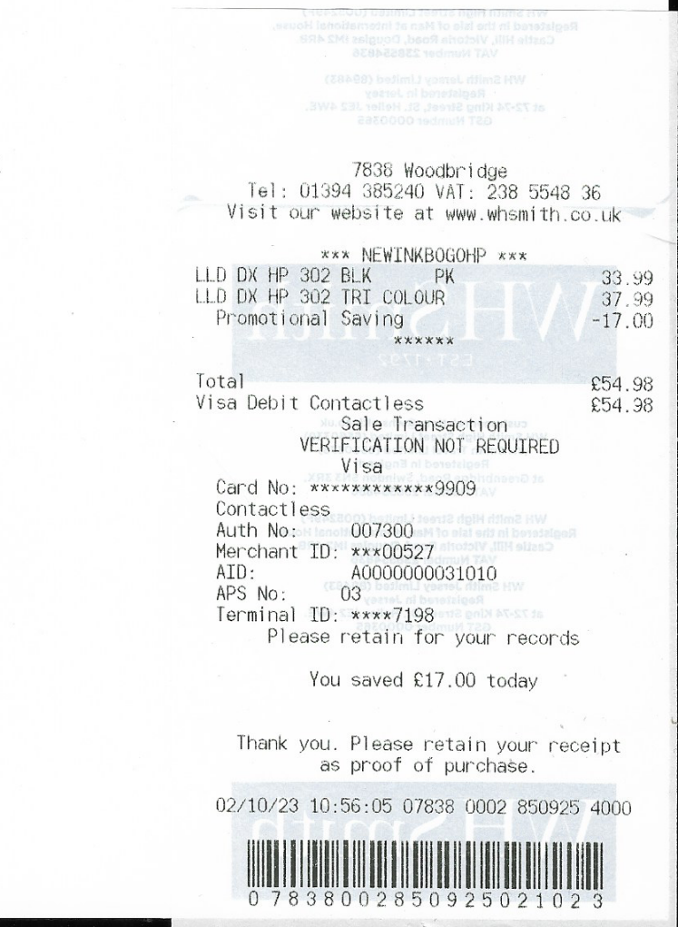

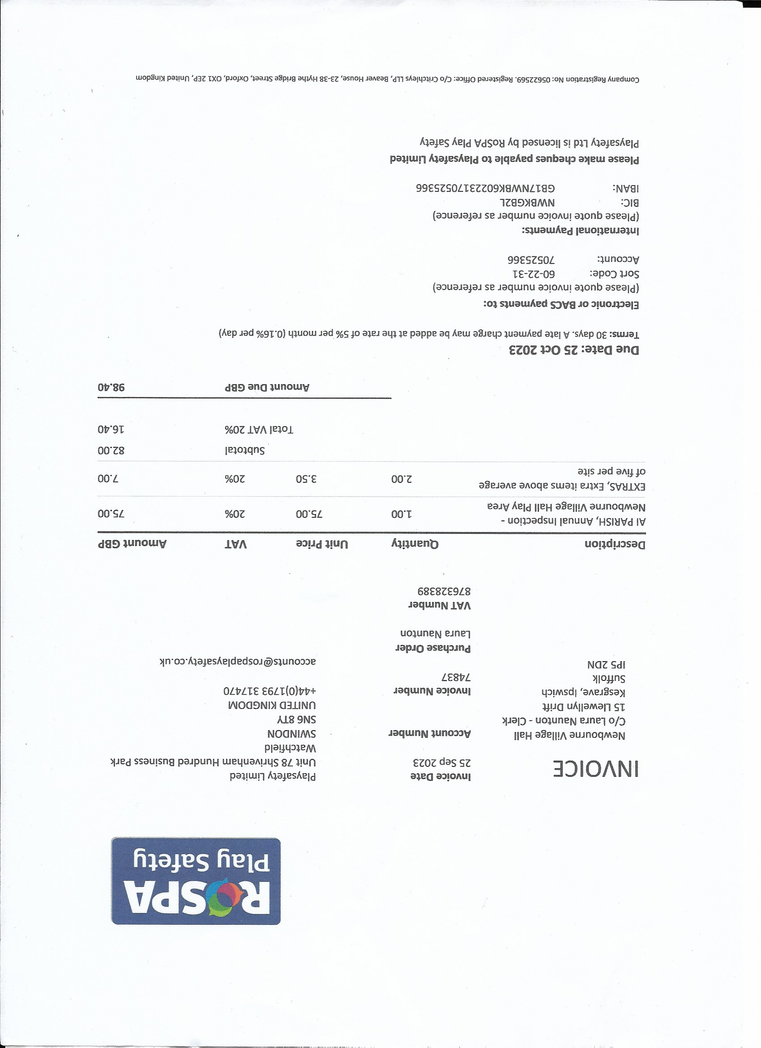

- Clerks Correspondence

- Spoke to planning enforcement and they advise that Narnia, Ipswich Road ENF/22/0326/DEV. They have been told by owner that planning will shortly be submitted if no planning application is submitted then a further site visit will be done and further enforcement action will be taken.
- Speed camera will be returned, and we will get a full refund.
- No update as yet on fridge/ freezers dumped off Woodbridge road.
- Tree’s reported on Woodbridge road as over hanging the road.
- Bus shelter needs a revamp any volunteers would be great.
- Bus time table included



