Newbourne Parish Council
Meeting 03/07/2017
Present Susan Harvey, Patricia O’Brien, Lionel Scott, Charlotte Gammons, Mick Frost, Jim Wicks, Tony Finch, Erica Pattison, David Milbourne, Sue Pollard
Absent Kwini Lusher
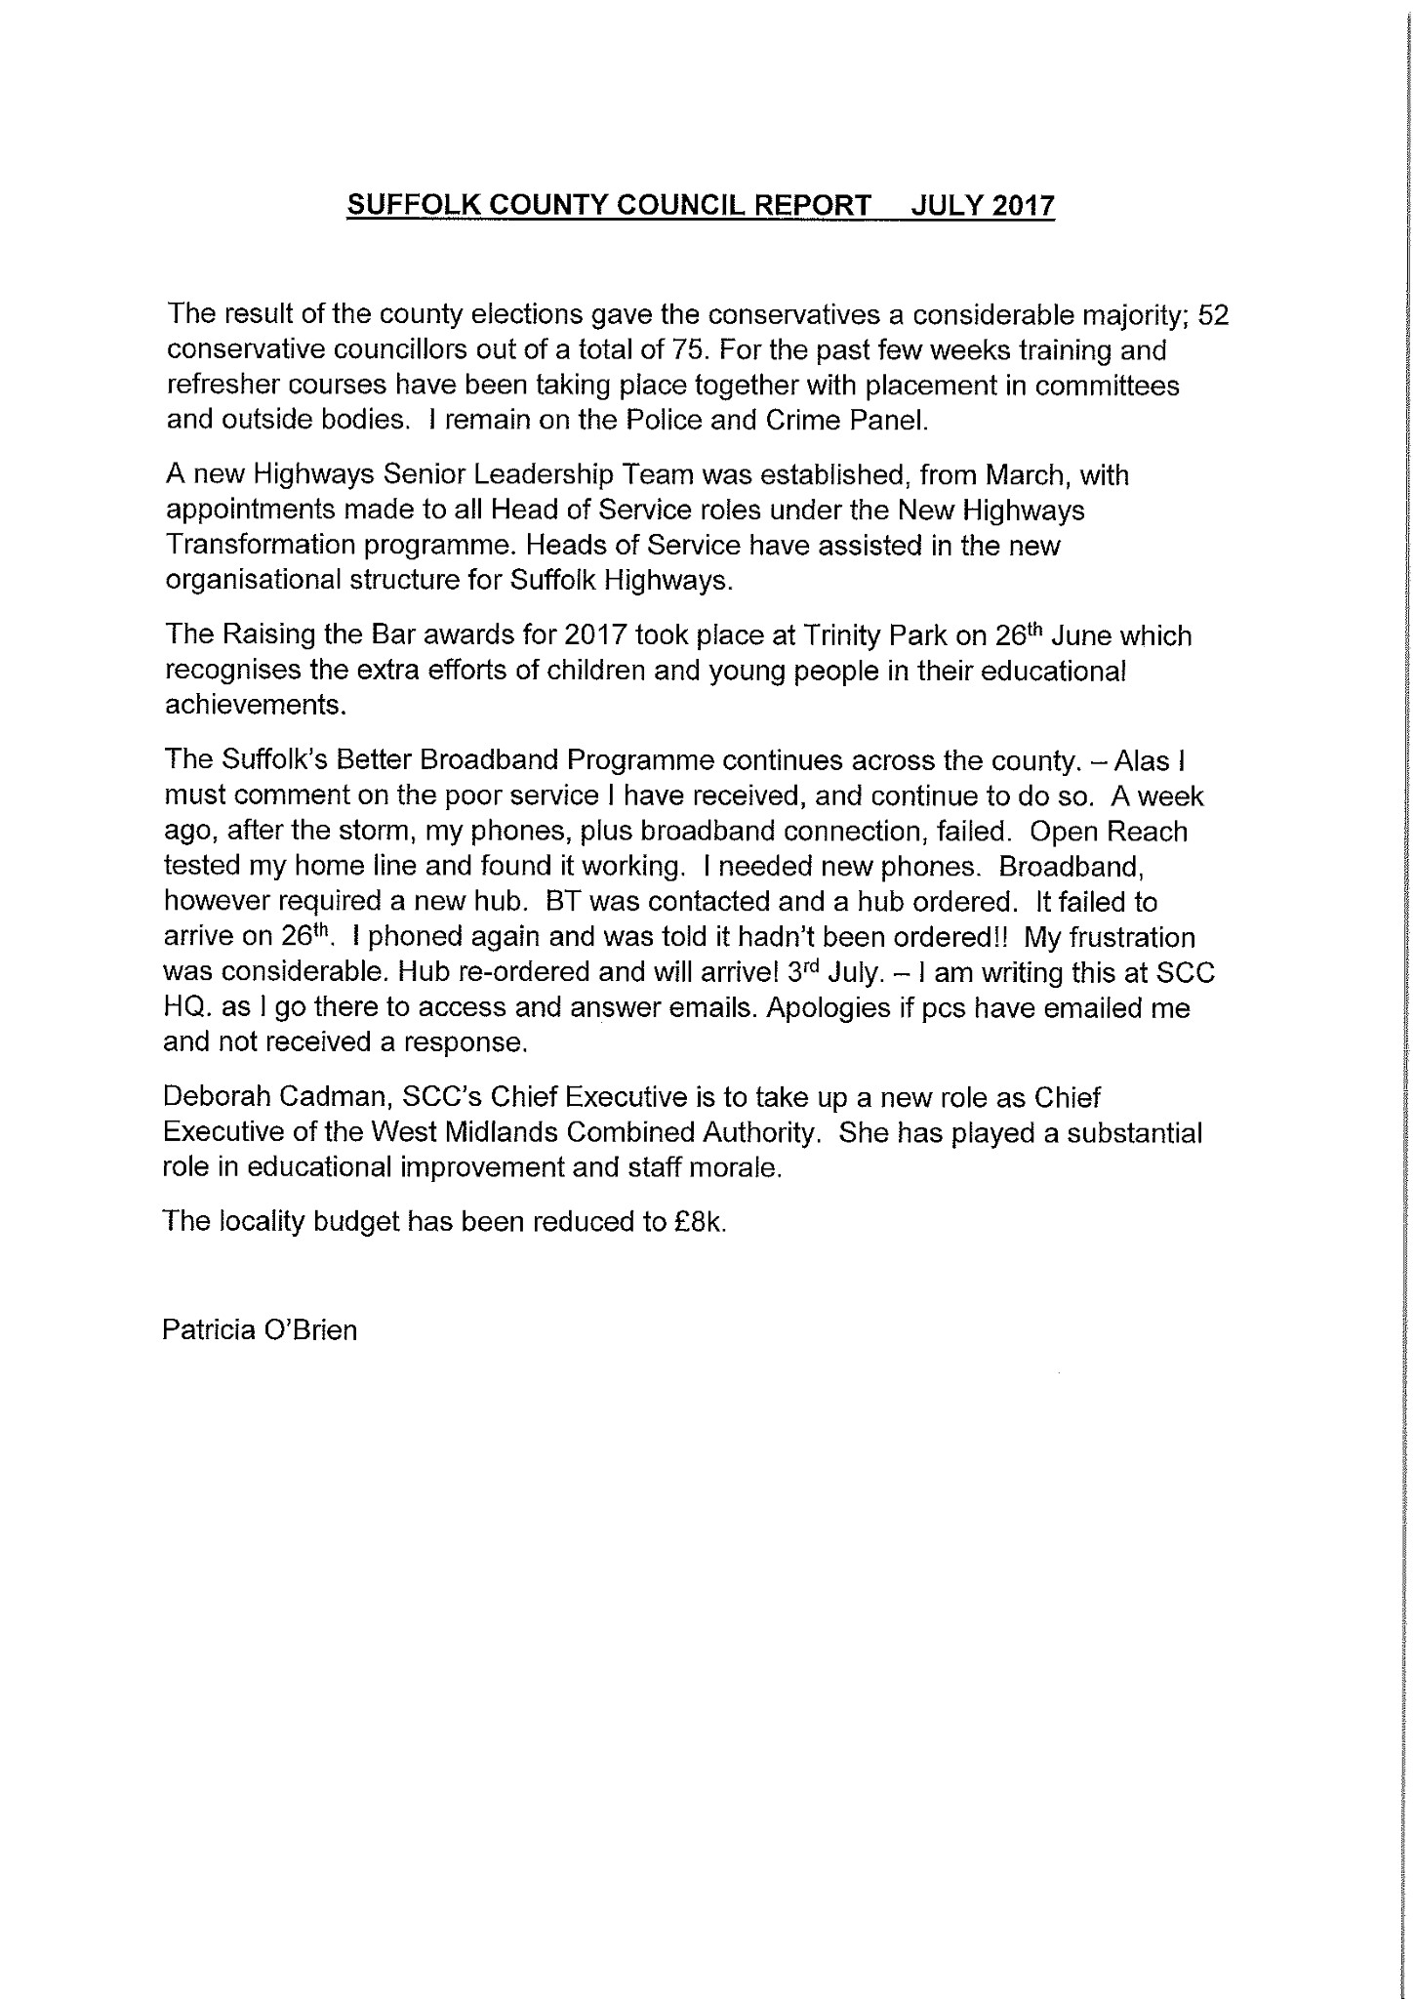
1. Patricia O’Briens Report
2. Susan Harvey’s Report
District Cllr’s Report for July Parish Council meetings.
Financial year Outrun Report 2016/17.
Through careful and effective budget management the Council delivered savings and achieved additional income which helped to meet spending pressures and reduction in Government Grant.

Operation Camouflage is being run again this year. This is a joint venture with the council and the Rocks Barracks. This is a wonderful week of entertainment, learning, exercise and fun based at the Rock Barracks for children from 8 to 16 years old. As the Rocks Barracks will be closing in a couple of years this wonderful opportunity will be lost.

East Suffolk House was officially opened by the Lord Lieutenant of Suffolk, Clare Euston on 15th June.
SCDC is looking to commission a local artist to create a new an exciting public piece of art and in return gain some recognition for their work. Details are on the Council web site.

Extra electrical Recycling Banks
There are new facilities for recycling small electrical appliances behind the Deben Pool and in Saxmundham. Since these facilities have been available 1500 small electrical appliances representing 2 tonnes have been recycled instead of going to waste. These sites are in addition to those at Felixstowe, Leiston and Foxhall.

Return of Women on Wheels. There are 2 rides taking place at Rock Barracks on Sunday 1st October. These are open to women and girls of all ages. Details on the SCDC web site.

The Coastal Conference is taking place at Trinity Park on Friday 6th October. Places are available.(www.eventbrite.co.uk/e/suffolk-coast-and-estuaries-community-conference-2017-tickets-26964786402 This year it focuses on Valuing our Coast. There will be speakers and workshops. This is usually a very interesting informative day.

Community Enabling Budget
I am reserving my budget for a while as there is a possibility of a Community Shop to serve Kirton and Falkenham and surrounding villages and I shall give it as much support as I can.

Review of the Core Strategy Document. This consultation will be coming out to everyone in August. This is your opportunity to have your say about the future of our villages until
2035. Are you happy about where your village sits in the ‘hierachy of villages’ table? Would you like to see a few more small affordable houses in your area to enable young people to move in, have your say on where new housing should go over the next 18 years? Building plots have been put forward in several places to take over 5 houses.

Merging of Waveney and Suffolk Coastal District Councils is moving forward. The number of Councillors considered necessary to manage a council will be determined by the boundary commission when they start their process later this year. It will probably end up between 50 and 60 instead of the 90 who serve the area at present. There will probably be 2 or 3 planning committees for practical reasons including the benefit of local knowledge and local decision makers and the need to travel to Waveney sometimes.

I have just been made interim Vice Chairman of the Planning Committee as our present Vice is not too well. This involves me in several more meetings.

*Contact Ben Woolnough regarding Adastral Park and set up meeting.
3. Planning DC/17/2273/PN3 Jackson Road
Previous planning in December 2016, no goods sold, receipts show that if eggs sold in fact a loss was made. It’s not an established agricultural business, nothing changed since November 2016, no business transactions.
DC/17/1435/OUT Adastral Park
Environment, traffic problems, not enough schools, doctors etc
Make contact with Ben Woolnough to arrange a meeting to discuss highway problems.
4. Play area
* Play area needs work doing to make sure it is safe
* ROSPA inspection needs to be booked in
* Get someone to inspect to see if bee nest is still live
5.
Speeding in the village, letter received about problems with speeding in the village and that 30 mph signs need to be moved to better locations to help reduce speeding.
Letter to be forwarded on to the highways department.

6. Finance
No cheques to be signed
Copy of bank accounts
John Jones lottery winner

Next Meeting 07/08/2017

…………………………………………
Chairman

